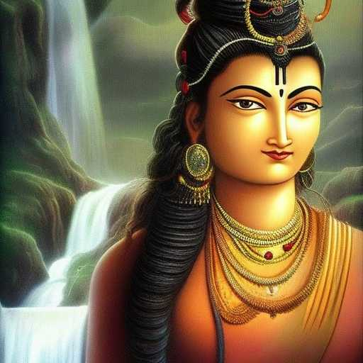
ISHANA ATMAN

My desire wants to make you into a woman because that is what my eyes know

But as I contemplate the five
heads of Shiva, I find Ishana Atman; and I know it not

The levels of Samsara cease
Forms become energies
For a moment, joys and sorrows are clasped in battle

But beyond is The Whispering Woman of the Waterfalls, who
loves me, not for who I am, because that no longer matters

She loves because She is love; and like stars upon
the primordial deep, She glistens eternally

